|  |
| --- |
| **LockedMe.com**  **(Application Screenshots)** |

**Version History**

|  |  |
| --- | --- |
| Author | K.Swathi |
| Purpose | Screenshots of the Application |
| Date | 10/08/2021 |

**Main Folder – To create a new >project >package>classes folder in eclipse**

**1.LockedMeMain.java**

**2.FileOperations.java**

**3.HandleOptions.java**

**4.MenuOptions.java**

**5.FileManager.java**

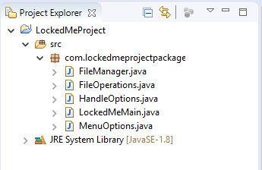

**2.Source Code :- (LockedMeMain.java) – To display welcome screen**

**(To display Application Name and the user details)**

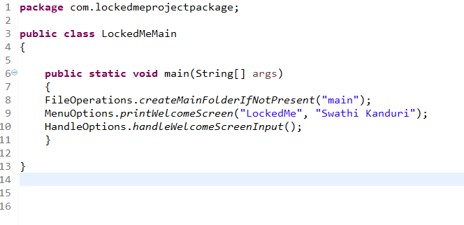

**Output:-**

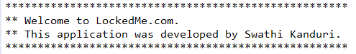

**3.SourceCode – HandleOptions.java – To handle file menu options**

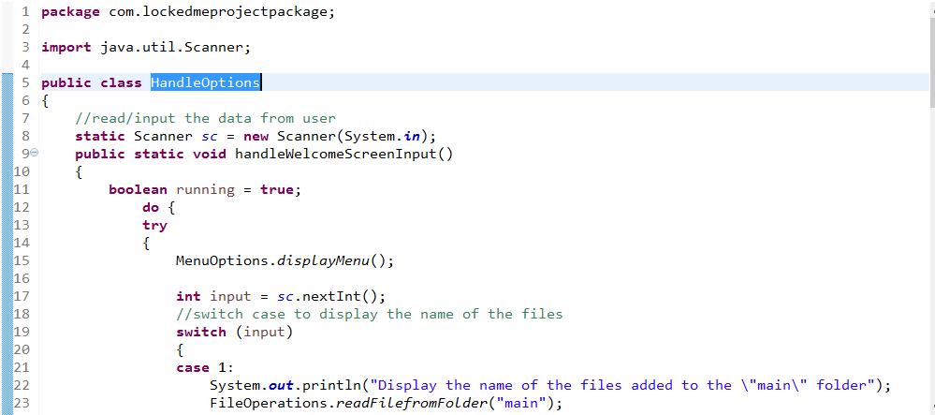

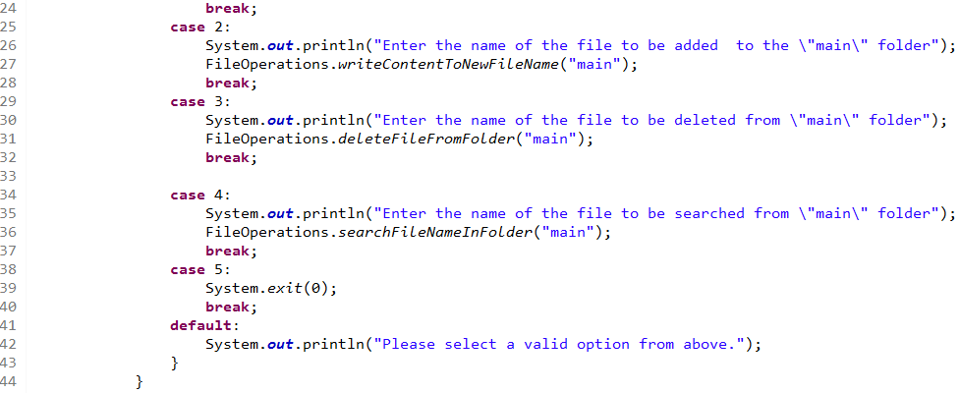

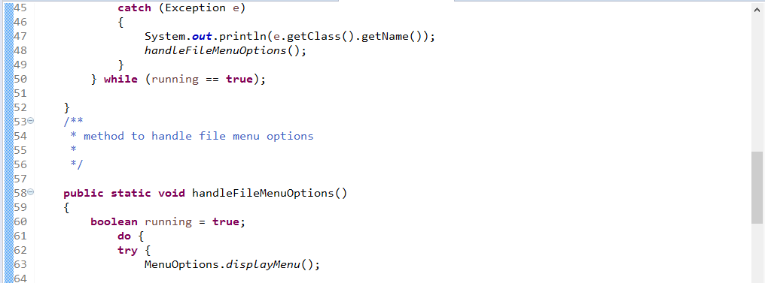

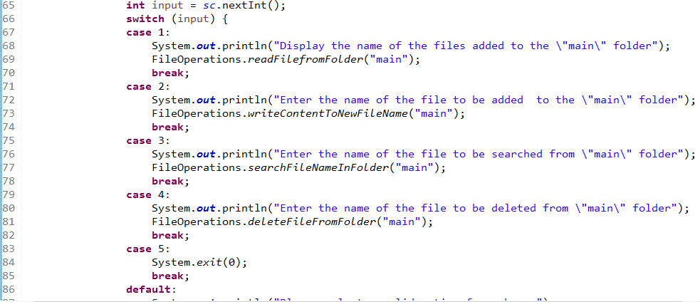

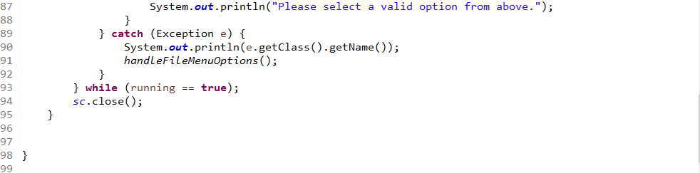

**4.SourceCode – FileOperations.java – To create main folder if not present, Search file name in folder, Read file from folder, Write content to new file, Delete file from folder, Display all files.**

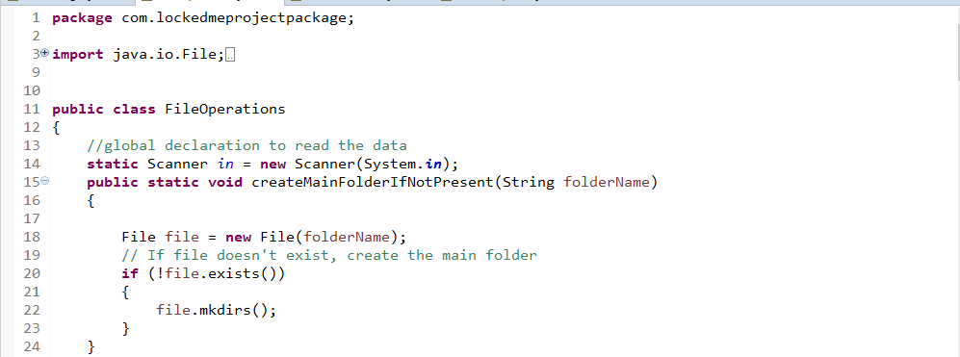

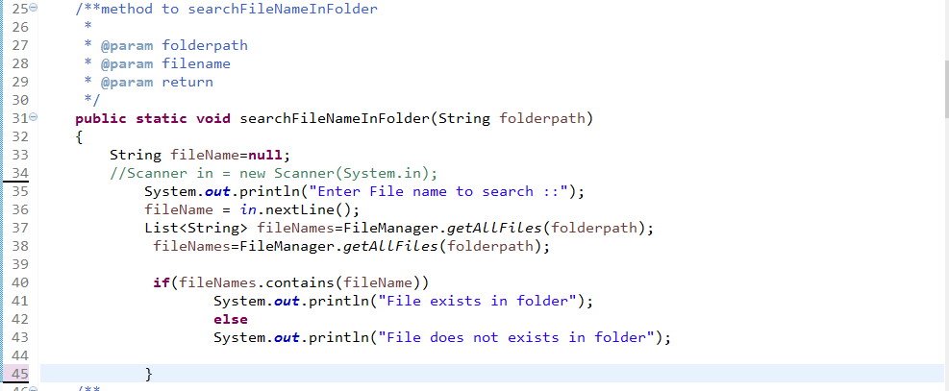

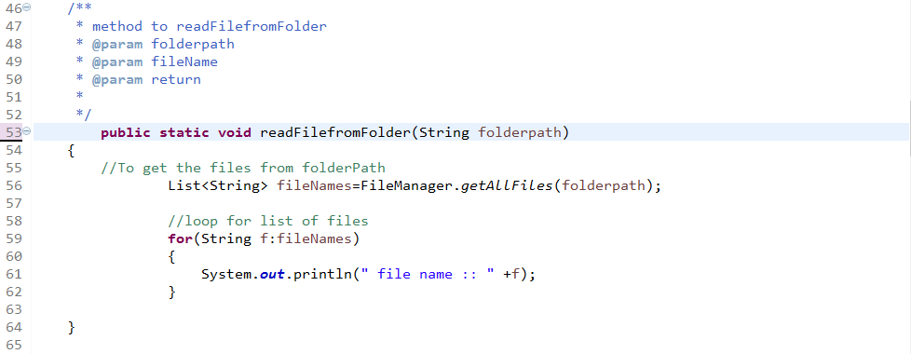

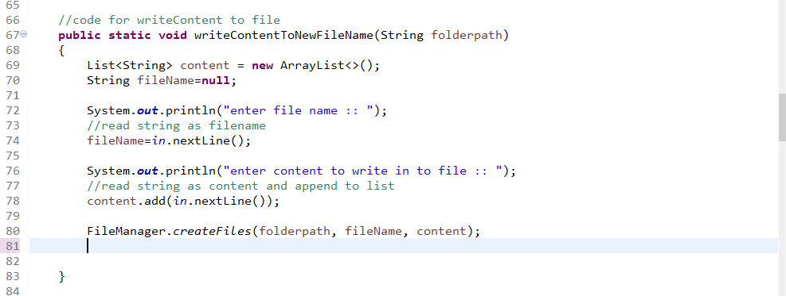

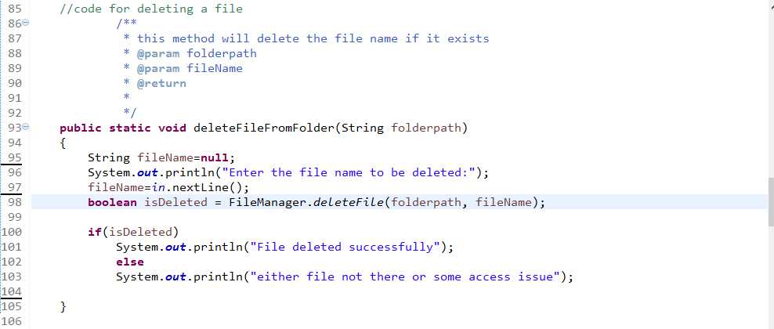

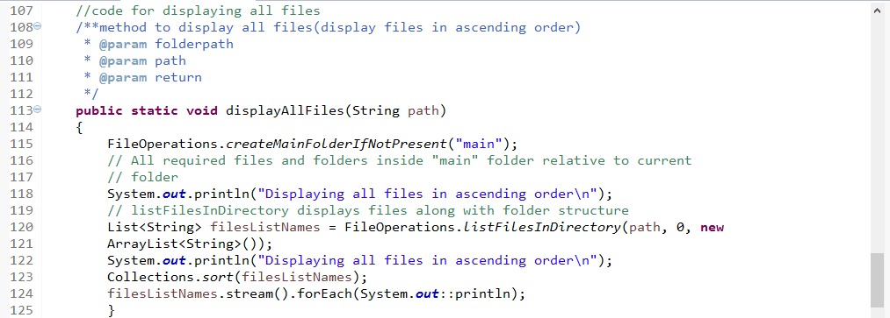

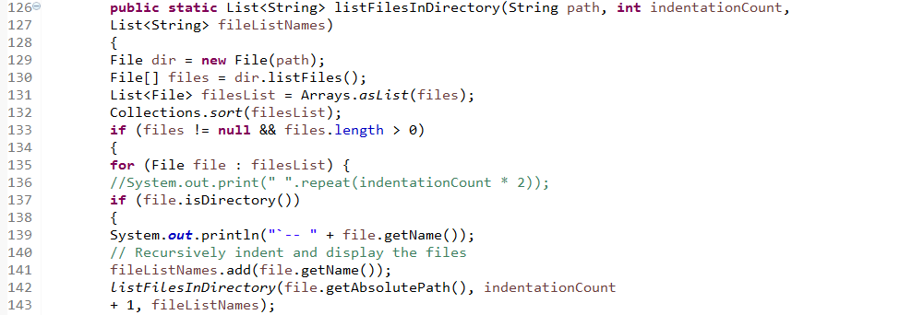

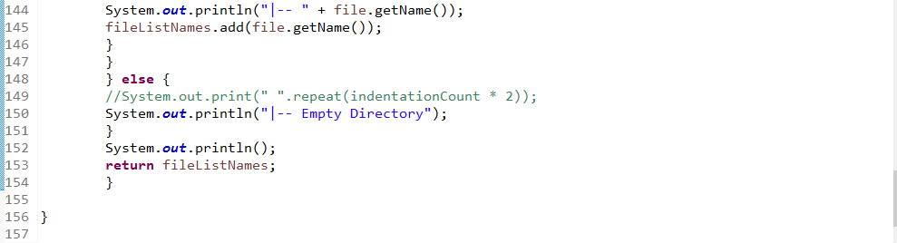

**4.SourceCode – FileManager.java – To create and delete methods**

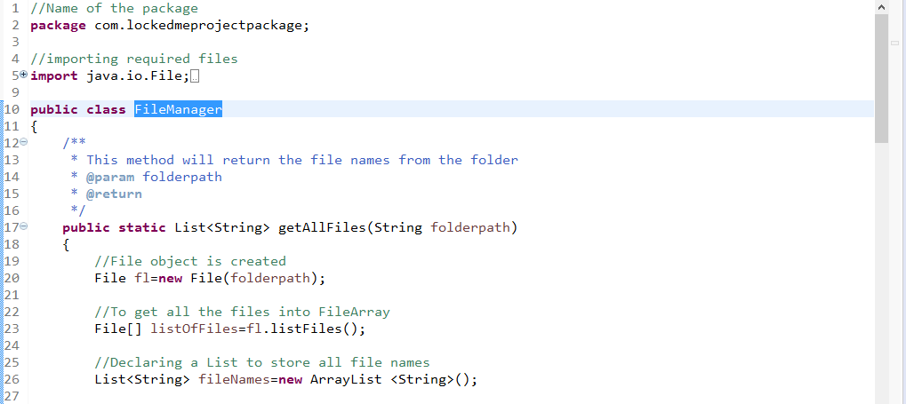

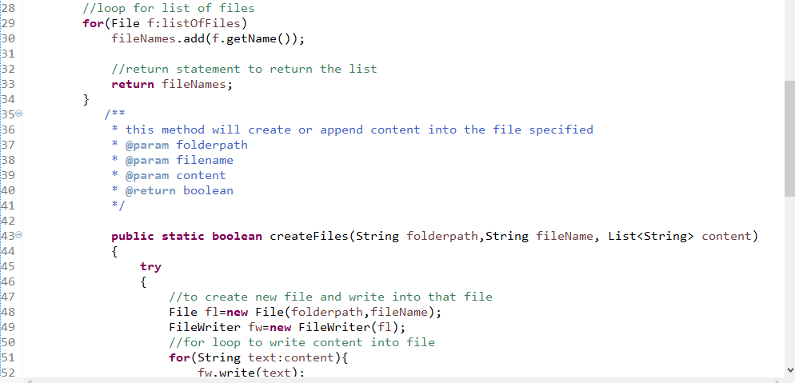

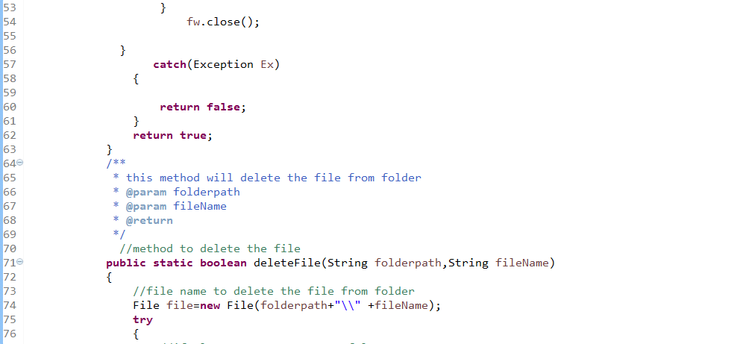

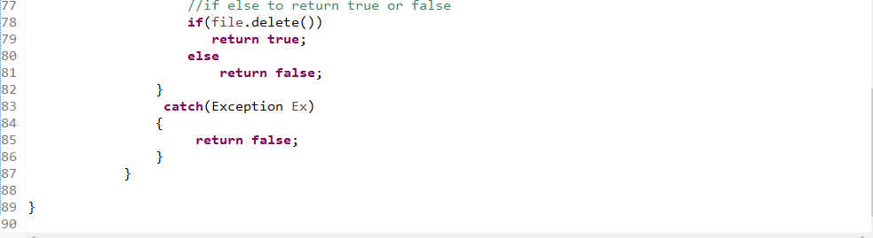

**5. Outputs:-**

**5.1Welcome Screen**

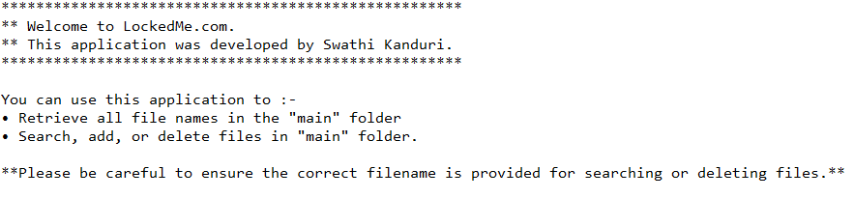

**5.2 Display Menu options**

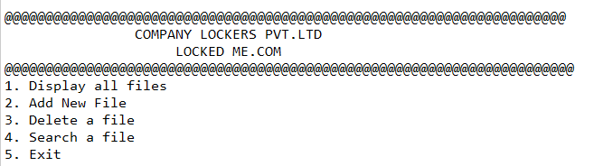

**5.3 Select the choice-1 and it displayed the files whatever added in main folder and displayed the names in ascending order**

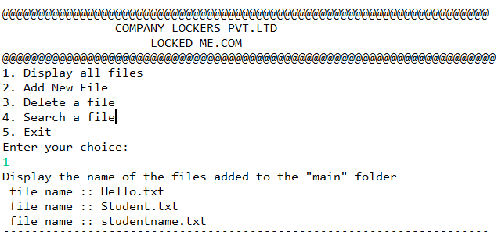

**5.4 Choice-2:- Add files to the existing folder**

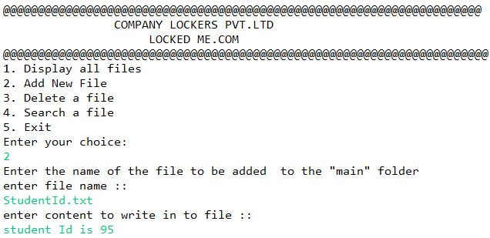

**Files displayed after adding the new file**

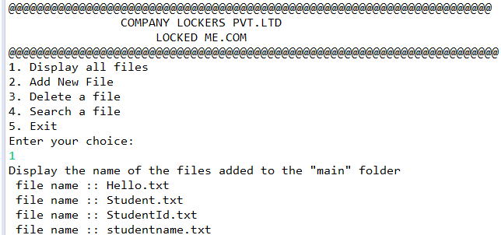

**5.5 Choice-3:- To delete file from main folder if file exists**

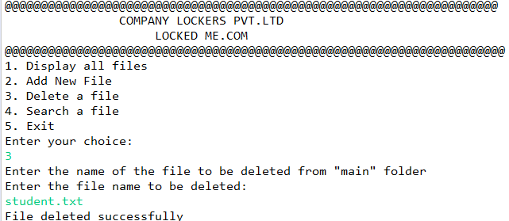

**To delete file from main folder if file not exists exists (FileNotFound)**

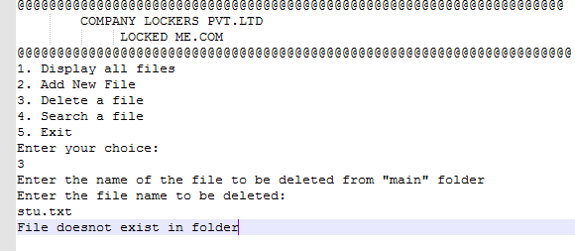

**5.6 Choice-4:- To Search a file from folder if exists(the operation is successful as file is exists in folder)**

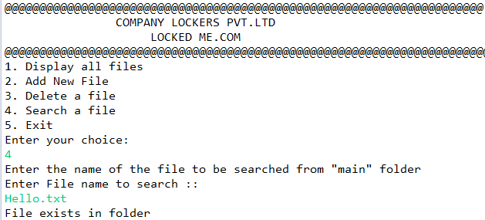

**To search a file from folder if file is not exist(the operation is unsuccessful as file is not exist in folder)**

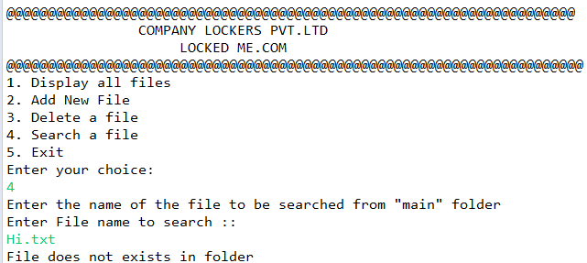

**Navigate Return to main menu**

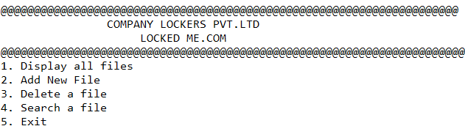

**5.7 Choice 5:-To exit from the application**

